Going to the Taft Theatre to see
The Wiz JR.
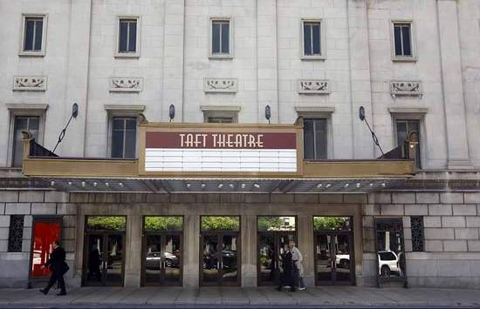

Macy’s is proud to partner with Cincinnati Children’s Starting Our Adventure
Right (SOAR) program to make these productions accessible to more children
and families. SOAR is made possible by Macy’s support.
Going to see The Wiz JR.
On Wednesday, April 6 I am going to the Taft Theatre to watch THE WIZ JR. The Taft Theatre is a place in downtown Cincinnati where people can go to see different shows. The show will start at 1 PM in the afternoon.
Actors, who are people dressed in costumes, will sing and act out the story of THE WIZ on the stage. I will get to watch the actors on stage and listen to them talk and sing. There is a movie and a TV program about THE WIZ. I can watch the movie or TV program, watch YouTube videos, or hear and sing the songs, but the show I am seeing is going to be a little bit different.
The show I am going to see will be a fun, musical show that children and adults will enjoy. I will get to join in on the fun if I want. The actors will be singing and dancing. I will hear songs that I might have heard before.

Getting to the Taft Theatre
I can ride to the Taft Theatre with my group/family. We can get dropped off or we can park in a parking lot or a garage close to the Taft Theatre. There are a few different places to park. My parents or guardians can look at the website to see where to park. My parents/group can tell me what we plan to do.
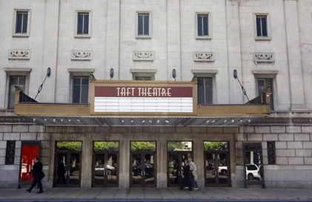
We will plan on getting to the Theatre at 12:30 PM. When we get to the Taft Theatre we will go inside the building, but first we have to put on our masks. We may have to pass through metal detectors first and let someone look in our bags, and they are going to ask that anyone over 12 years old shows their COVID vaccination card or a negative COVID test result.
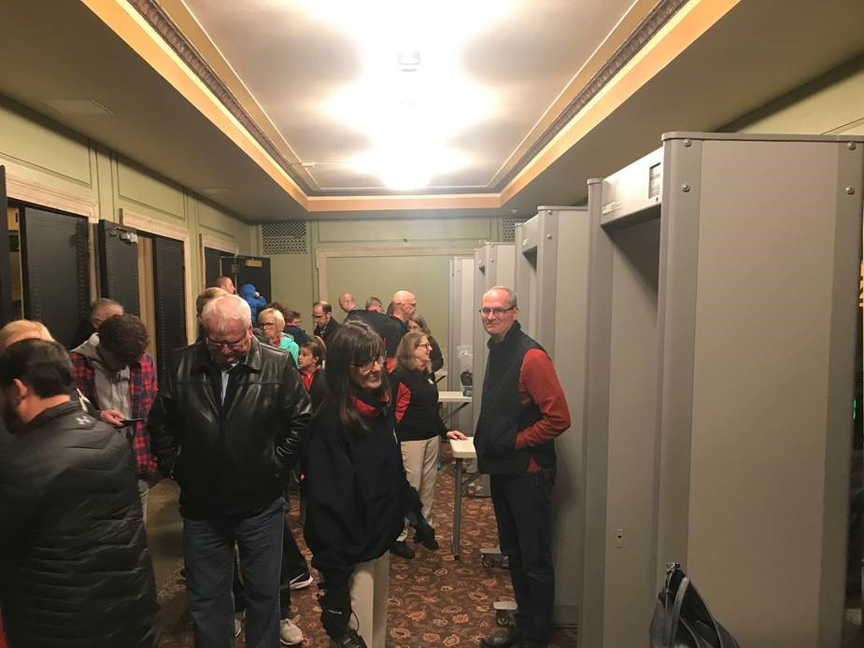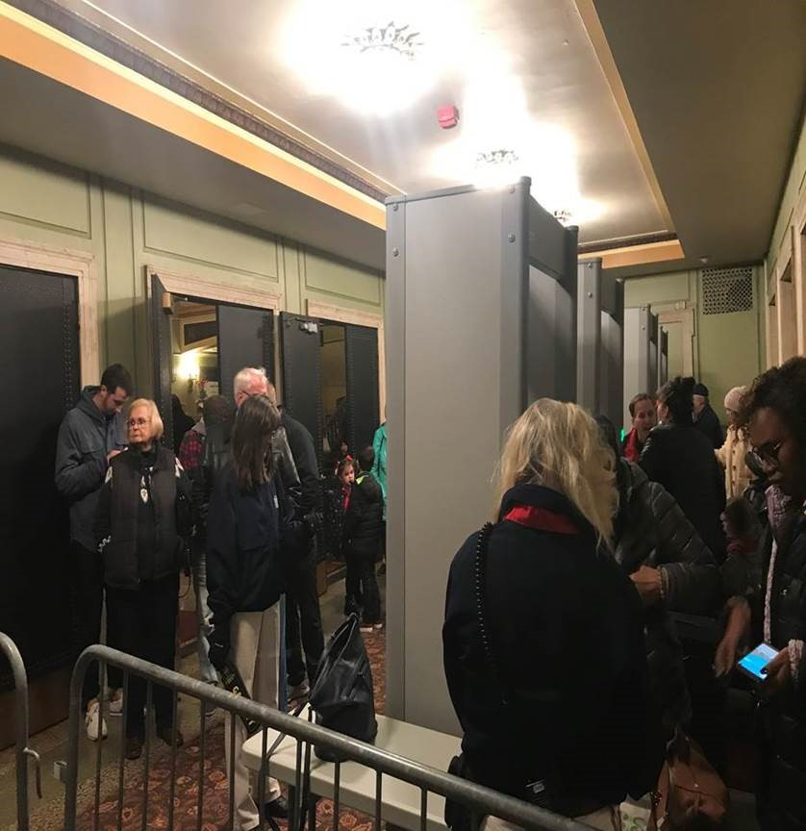

At each door, there will be volunteers. They will be wearing special nametags. They will greet us at the door and can help answer questions and show us where to go. I can say “hi” or “good morning” to the volunteers.
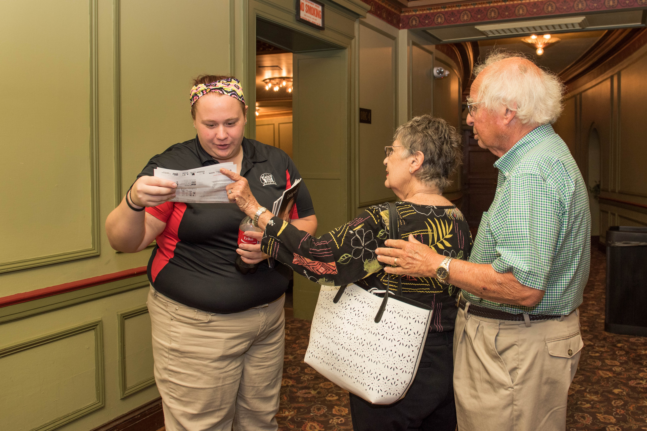

In the lobby
Inside the lobby, we will see other people who are coming to see THE WIZ JR. and people who volunteer or work at the Theatre. There will be closed signs hanging up to remind me when I should not touch something or if an area is closed. There are two levels at the Taft Theatre. For this special performance, only the first level will be open. I will see a closed sign and tape blocking the stairs that go up to the other level because upstairs is not available.

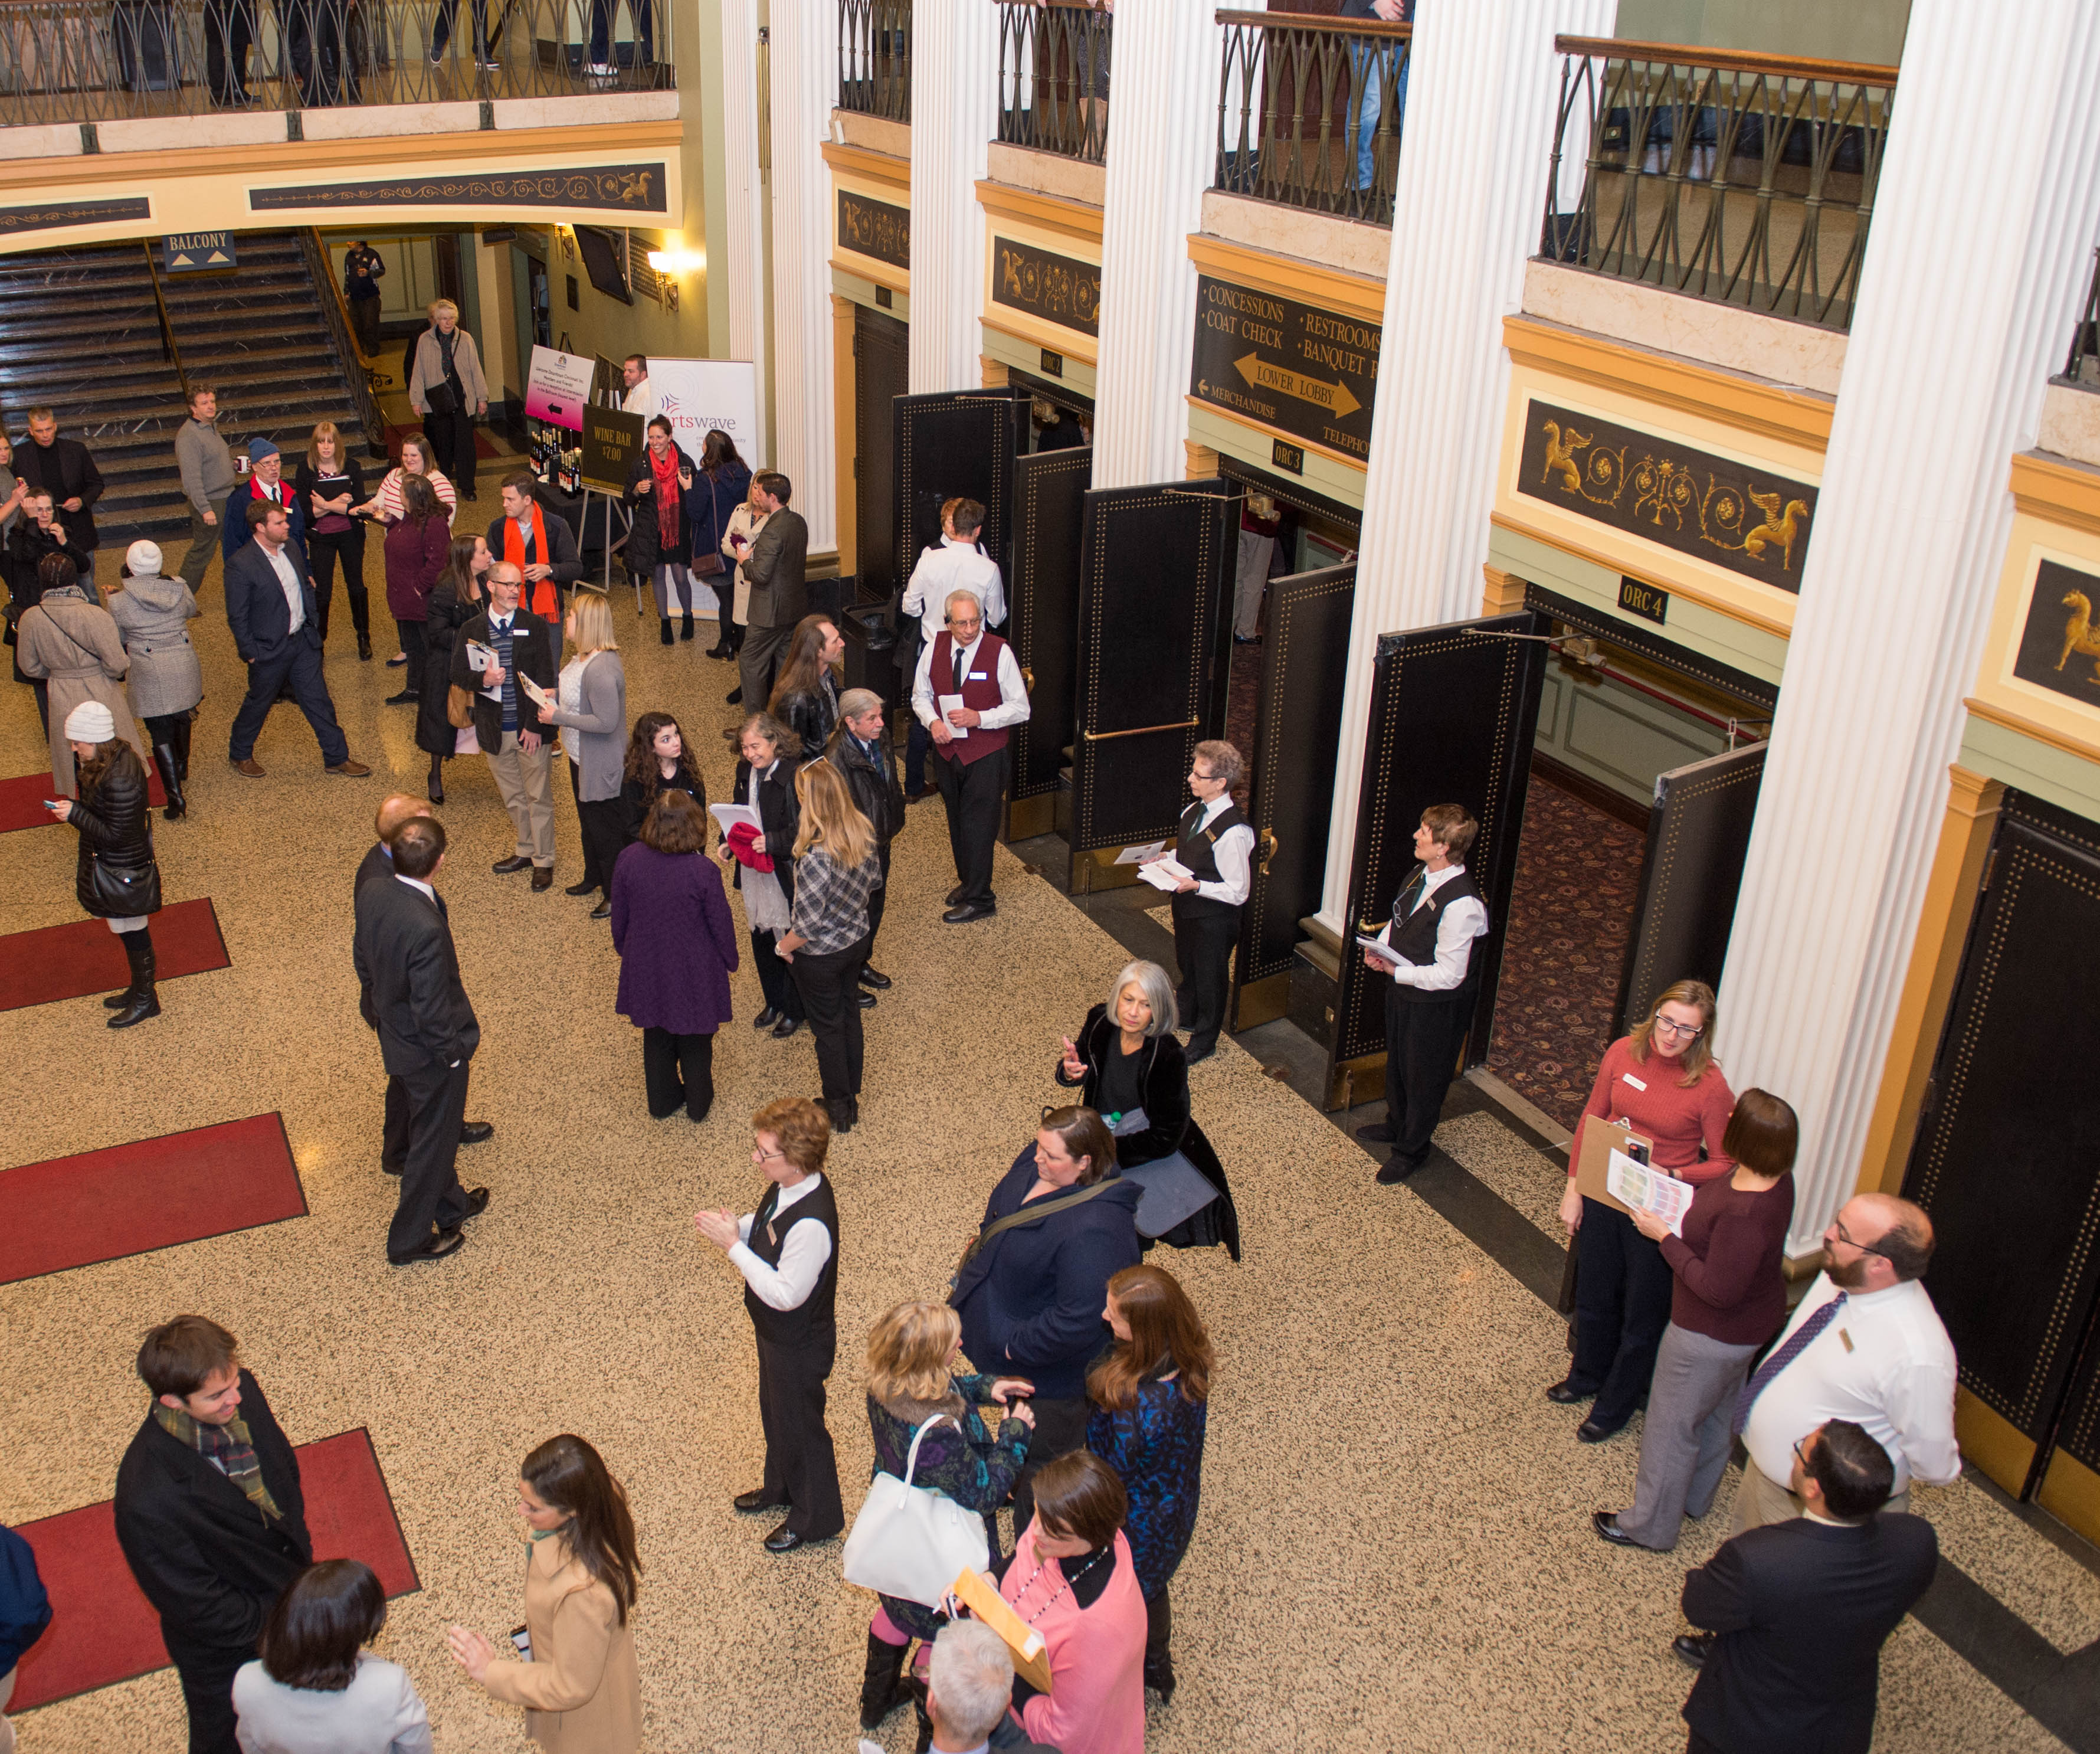

There will be lots of people coming to see THE WIZ JR. so it is important for me to stay close to my parents/group so that I stay safe. It is also important for me to stay calm and wait my turn if I need to. I can bring some things from home in a bag to do while I wait. If I think it might be too loud in the lobby, I can cover my ears or pack headphones to wear.
The show starts at 1 PM. The doors to the Theatre will open at approximately 12 PM. If I am early, I will have to wait to go inside the Theatre. While I wait, I can look around the lobby, go to the restroom, eat a snack, or play with the things I brought from home.
Food and Drinks
This is a special performance and I am allowed to bring snacks and drinks from home and take them inside the Theatre. They will not be selling snacks or drinks at the Taft Theatre for this performance. I will keep my mask on when I am not eating or drinking.
Restrooms
If I need to use the restroom, there are 3 restrooms available to the right of the lobby. The restrooms are hand flush and have paper towels that I can use to dry my hands. If there are a lot of people who need to use the restroom, I may need to wait in line. I will try to be patient and wait my turn to use the restroom.
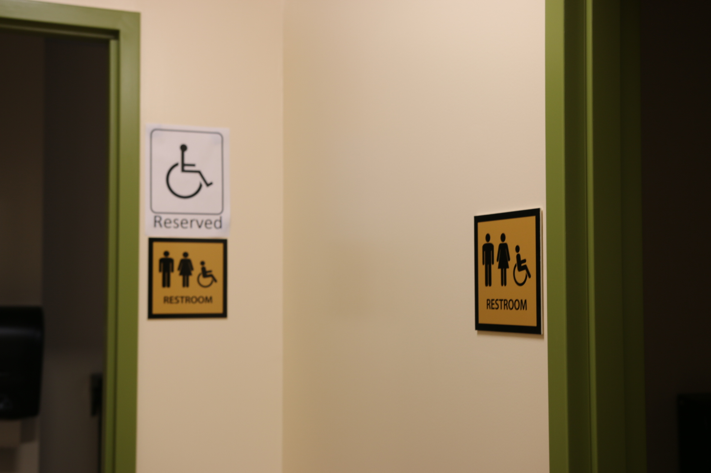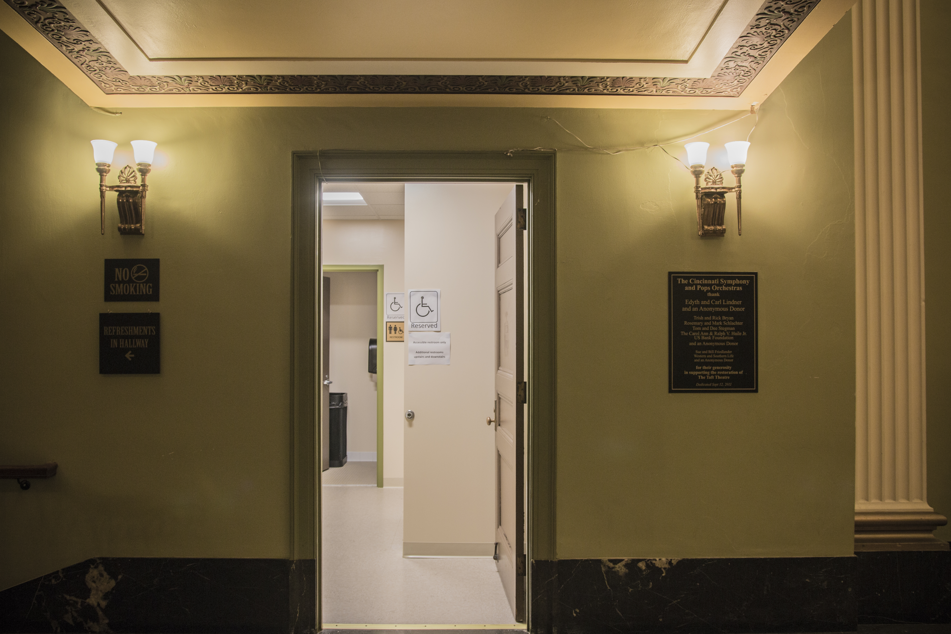

Quiet Areas
For this performance, there will be a quiet area that is available for me if I need to take a break or would like to go to a quiet space with fewer people. I can tell my parents/group that I need to take a break and we can go to this area. The quiet area will be down a hallway. There will be a sign that says “Quiet Area.” I can go to the quiet area before, during, or after the show if I need a quiet space. There will be headphones and fidgets in the quiet area if I need them.
Entering the Theatre
When it is time to go into the Theatre, I will enter with my family/group. When I go inside the Theatre I will see lots of seats. Each seat has a letter and a number. The seats are all facing the stage. All the people who sit in the seats to watch the musical are called the audience. The usher will show me how to get to my seat. I can look on the Taft Theatre’s website to see a map of the Theatre. I may get a program from the usher that tells me more about THE WIZ JR. While I wait for the show to start, I can look at my program to learn more about the actors. There will also be some TV screens to look at with details about the show and The Children’s Theatre of Cincinnati, along with trivia and quizzes for fun.
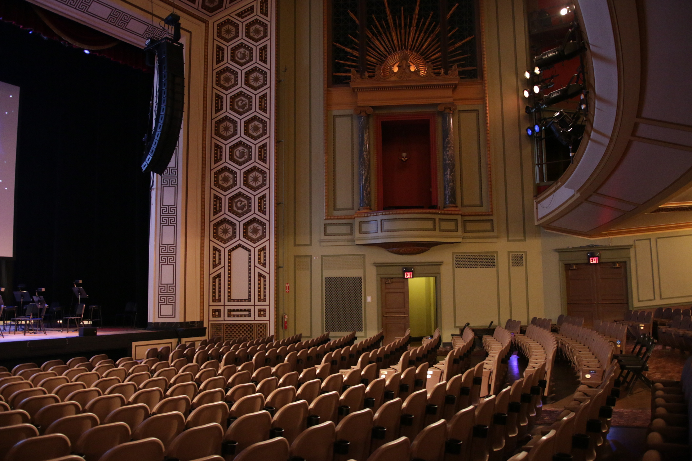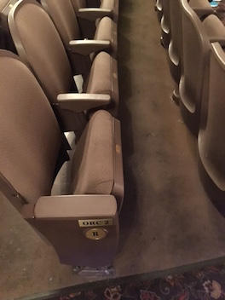
The stage is where the actors will perform. I will stay off the stage and down with the audience. It is important to sit in my chair during the show so that the people sitting behind me can see the stage.

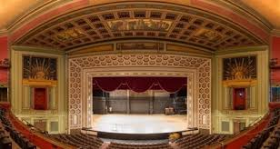

Watching THE WIZ JR.
When it is time for the show to start, there will be a short announcement and the lights will get a little bit darker but won’t turn off. They will stay at half brightness during the show. The curtain will go up and I will see the stage and the actors. The actors will be wearing different costumes to help tell the story. They will be wearing makeup and hats. They are pretending.
The actors will come on and off stage during different parts of the show. Lights will be used on the stage to make it look like day time and night time. Sometimes a light will shine on one part of the stage if there is something important for the audience to see. I can follow the light with my eyes to look at the important things. I will hear music and special sounds that help tell the story. If the sounds are too loud, I can cover my ears or wear headphones.
If I need a break during the show, I can tell my parents/teachers and they can walk with me out of the theater. Since this is a special performance, it is okay to get up and take a break during the show. If I take a break, I can walk around in the lobby or go to the special quiet area. I can also visit the restroom. I can come back to watch the rest of the show when I am ready.
The musical will last about 60 minutes, or about one hour.
There are different scenes in the show. I can learn more about these scenes and characters in the Timeline and Character Guide.

At the end of the show, the curtain will close and the audience will clap for the actors. The actors will take turns coming onto the stage so that the audience can clap for them. I will clap my hands to show the actors that they did a good job. The actors will take a bow or curtsey while the audience claps. Sometimes when the audience really likes the show they will stand up to clap. This is called a standing ovation. This shows the actors that they did a great job! When the clapping slows down, the actors will take a final bow together. The curtain will close and the lights will come back on in the theater. This will mean that the show is over.
I will look around my seat and make sure that I pick up all my things before I leave. I will keep my mask on and walk to the aisle and wait with my family or group to walk out of the theater. There will be lots of people leaving the Taft Theatre at the same time. I will try to be patient while I wait my turn to walk up the aisle and into the lobby. I can stop at the restroom if I need to on the way out of the theater. I will walk with my group/family with our masks on through the lobby and to our bus or car.
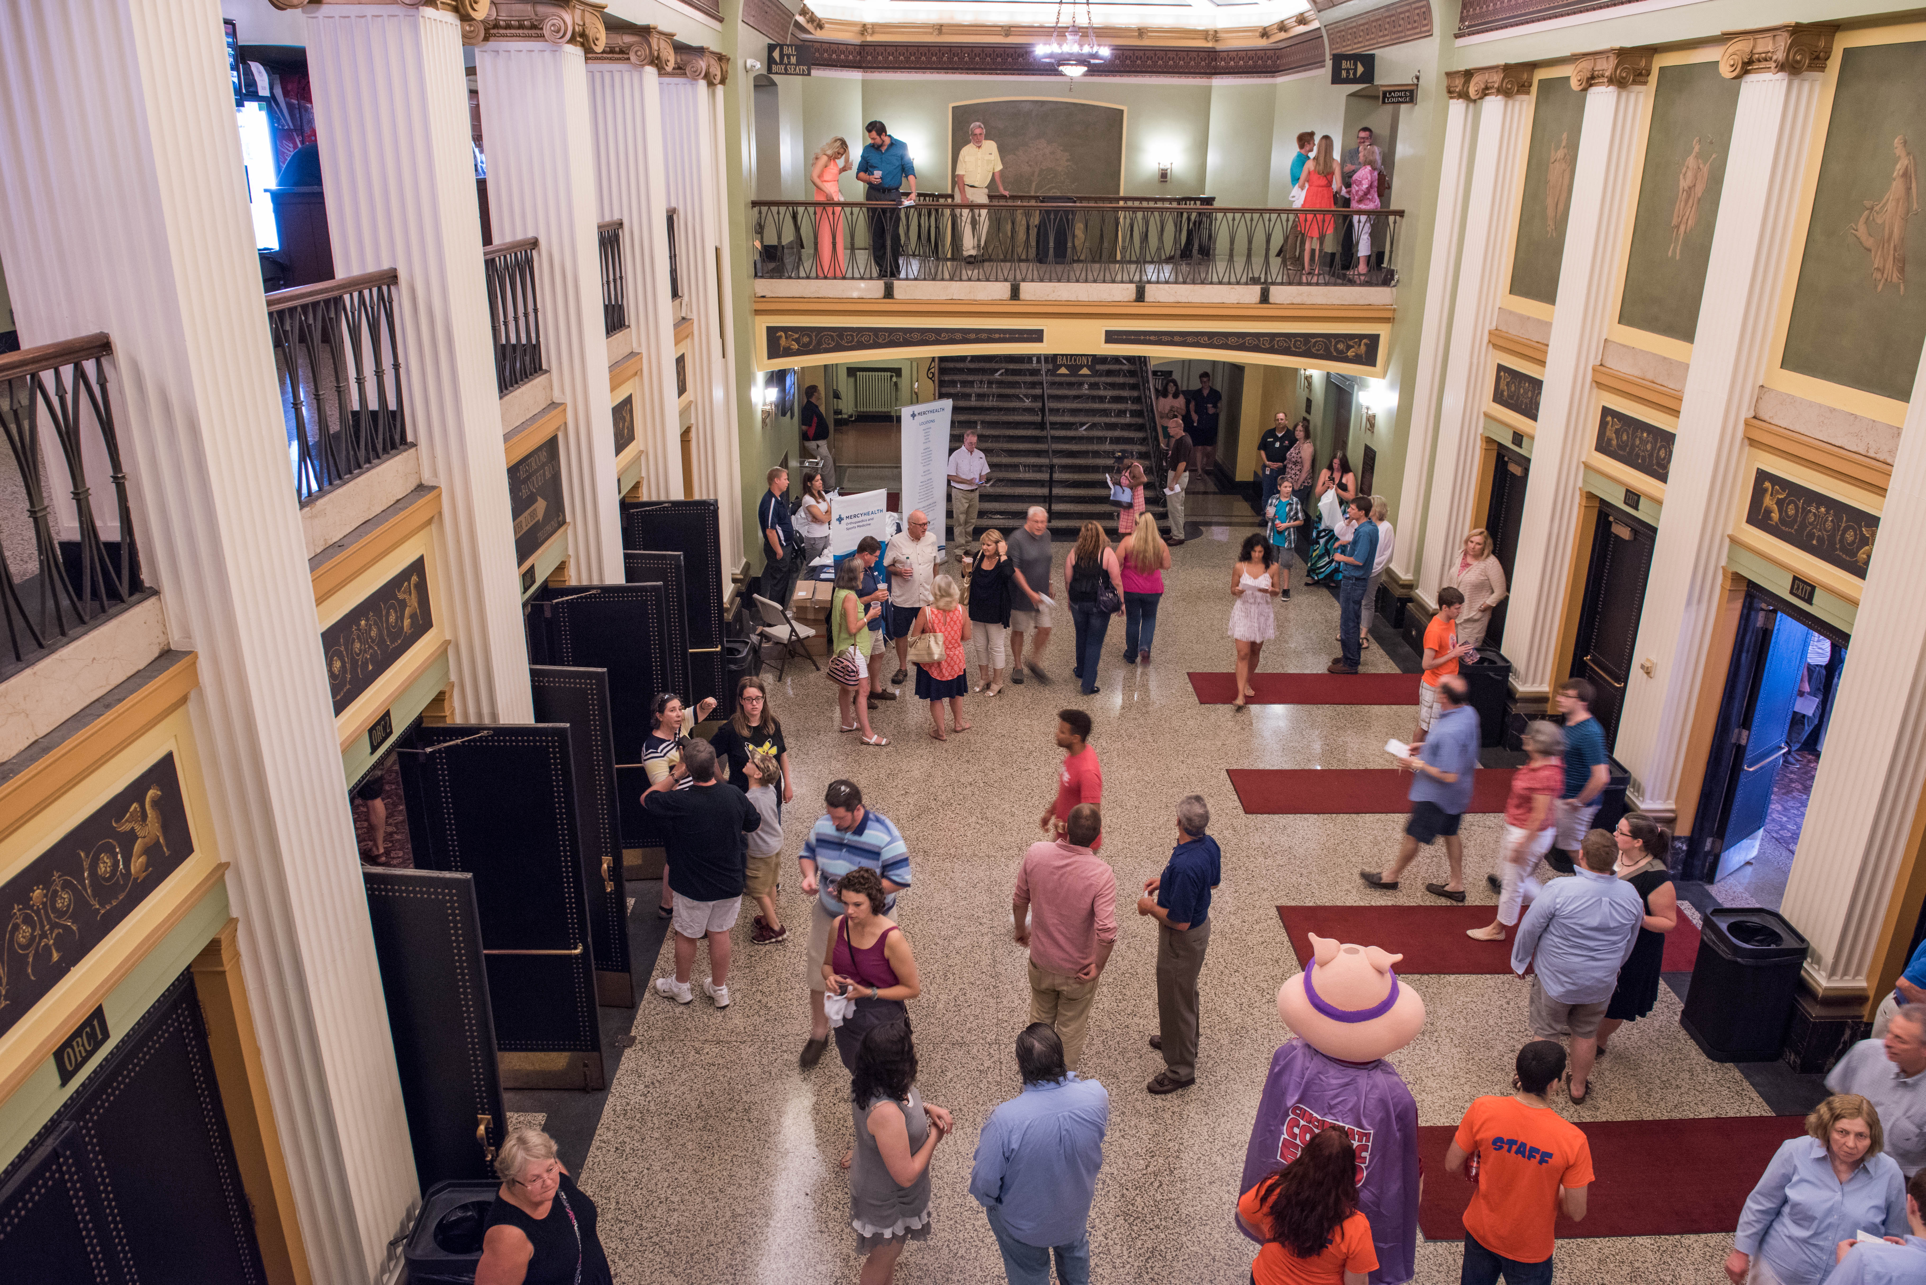

*Photos courtesy of Cincinnati Symphony Orchestra, MEMI, Cal Harris, Mikki Schaffner and The Children’s Theatre of Cincinnati.

